

**KNOWLEDGE MANAGEMENT SYSTEM**

**WINTER SEMESTER 2021-22**

**School Of Information Technology &Engineering**

**Symptoms Analysis System**

**Team Members:-**

**S DEEPAN :-19MIS0102**

**Project synopsis or Abstract**

**Introduction**

**General overview or background of the project topic/ domain**

In this issue, we focus on the infrastructure workstream of the Future Hospital project, and notable figures provide their perspective on the built environment and specific elements of healthcare infrastructure, including architecture, design, commissioning a new hospital, sustainability and information technology, both in the UK and overseas. Particular thanks are due to Tom Downes for editing this special section.

Infrastructure must integrate the hospital, as the centre for acute and inpatient care, into the broader health care system,1 and should facilitate the seven domains of quality2 – patient experience, effectiveness, efficiency, timeliness, safety, equity and sustainability. Infrastructure includes the built environment and supporting elements: equipment, access, information technology (IT), systems and processes, sustainability initiatives and staff. Overall these interwoven facets should enable patients to move seamlessly, with their privacy and dignity maintained at all times,3 from initial referral through local hospitals to specialist tertiary centres and discharge to appropriate care (home, care home, or community hospital with intermediate care), whatever the age, disorder or social circumstances of the patient.

**Literature survey**

**Overview of the proposed project**

**Motivation**

The moto behind the project is know a days all are using internet in different department like online classes, online shopping , online bookings, for cinema, for travelling, etc, .So why we cant we use this online website for hospital system .

**Aim**

The aim of the project is to bring the online hospital system to the society and decrease the paper work .

**Objectives**

* The Hospital Interface Application is designed for any hospital to replace their existing manual paper based system.
* The new system is to control the information of patients.
* Doctors availability, staff schedules , patients invoice, discharge summary and Appointment Bookings.
* These services are to be provided in an

1. efficient manner.
2. cost effective manner.
3. with the goal of reducing the time and resources currently required for such tasks.

* To be Carried out in a Logical and User-Friendly way.

**Development tools and methodologies used**

The tools used is visual studio for coding and coming to the methodology we use HTML,PHP,JS,CSS for style, and some knowledge management systems.

**Requirements Specification**

**Functional requirements specifications**

* We aim to design a hospital interface for patients and even doctors to effectively and easily interact with the system.
* Patients can book appointments online and can access entire records history.
* Multitasking can be possible (other activities can also be done by the users, while booking)
* Doctors can view their daily schedule and also the appointments which he/she must attend.
* Once the consultation of particular patient is over, Doctor can upload the reports/Medicines prescribed in the patient’s portal for future reference

**Non- functional requirements specifications**

**Performance Requirements:-**Some Performance requirements identified is listed below:

* The database shall be able to accommodate a thousand record to store.
* The software shall support use of multiple users at a time.
* There are no other specific performance requirements that will affect development.

**Safety Requirements:** The database may get crashed at any certain time due to virus or operating system failure. Therefore, it is required to take the database backup.

**Security Requirements**: Some of the factors that are identified to protect the software from accidental or malicious access, use, modification, destruction, or disclosure are described below. Keep specific log or history data sets

* Assign certain functions to different modules.
* Restrict communications between some areas of the program .
* Check data integrity for critical variables .
* Later version of the software will incorporate encryption techniques in the user/license authentication process.

**Design constraints ,if any**

i)A PC with windows 10/9 64 bit support configuration.

ii) Processor – Minimum 1G hz.

iii) Atleast 2GB RAM.

iv)Display with SUPER VGA Resolution.

v ) Stable Internet Connection(LAN).

**System Architecture and modules**

**Modules**

1. **Admin login:-**The Admin will do the infrastructure of the system and he need to collect the details of all hospitals in all locations and doctors, departments of the doctors, categories, locations of the hospitals. And provide the doctor module to doctor for there needs and references

as same for the patient to book the doctor for there problems and which categories there are belong to . Controls the status of the fee payment .Edit details of the students& modify the student records**.**

1. **Doctor module:-**In this module all the doctors are present where the admin as given .And also the doctor will see how many users(or) patients booked him/her and this module is purely the doctors thing.
2. **Patient module:-**In this module users or the patients come to login and see the available doctors and under which category they are belongs to location of the doctor (or) hospital ,and they can book there doctor to solve there problems by date, time, day .Finally a user can see the ratting of the doctors &feedback .

**Detailed design**

**Coding or implementation**

**Output Screenshots :**

**Main Interface file for admin,doctors and patients :**

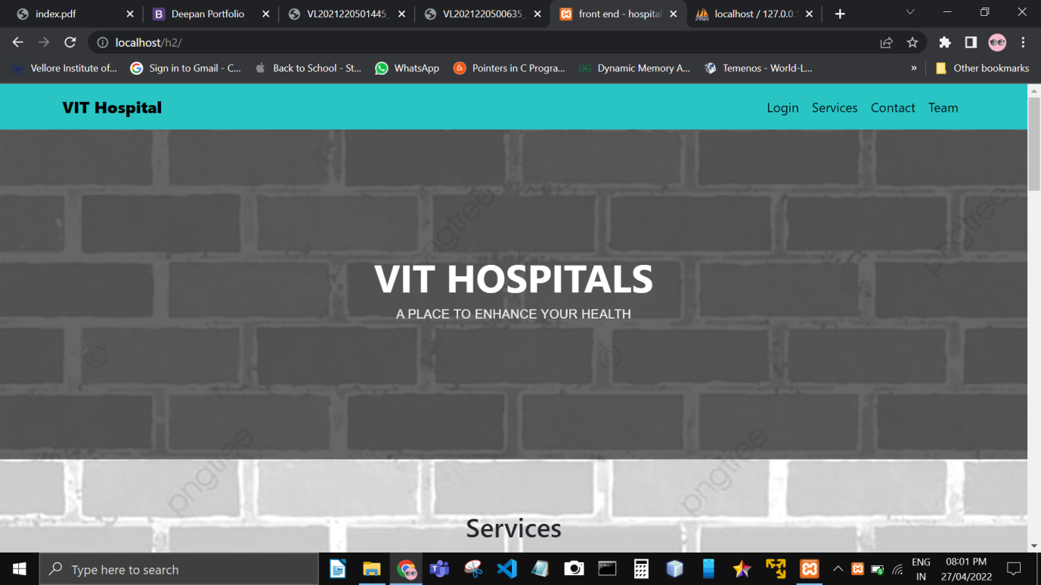

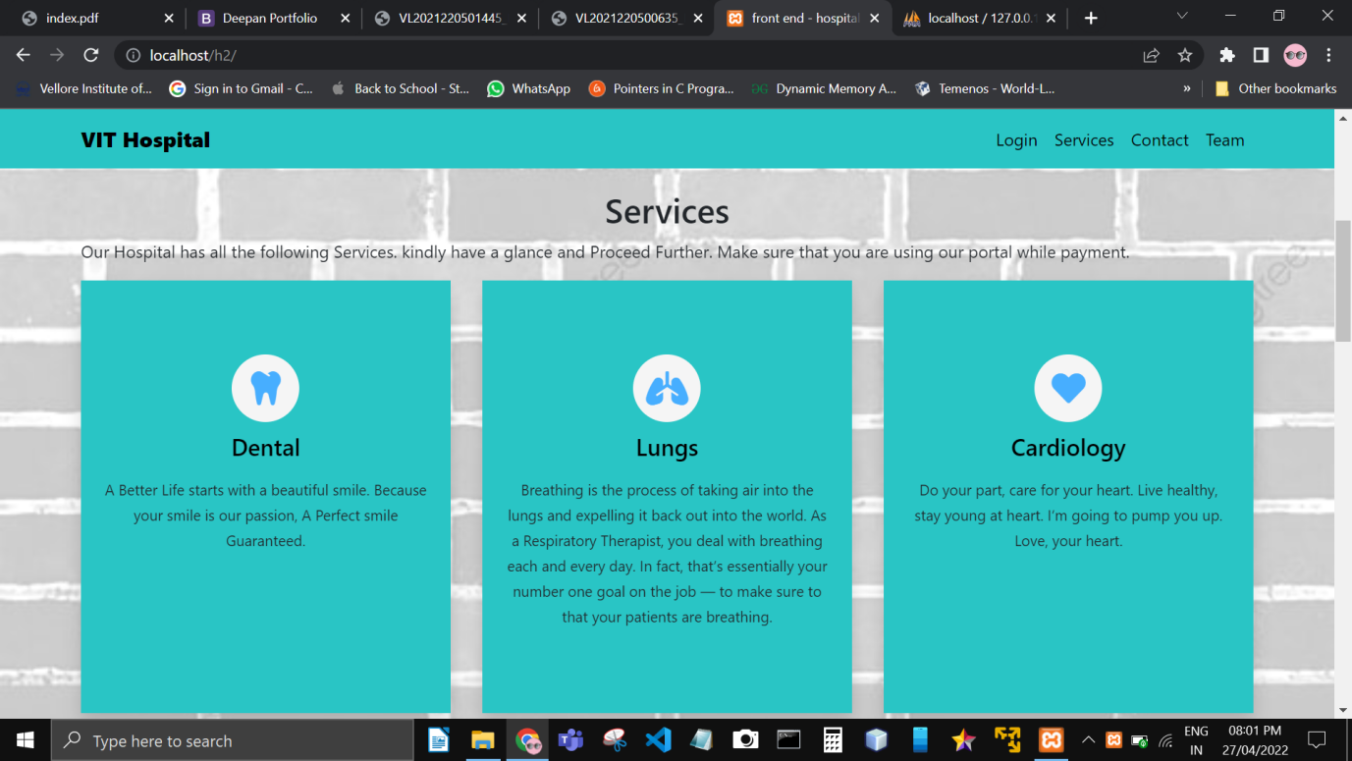

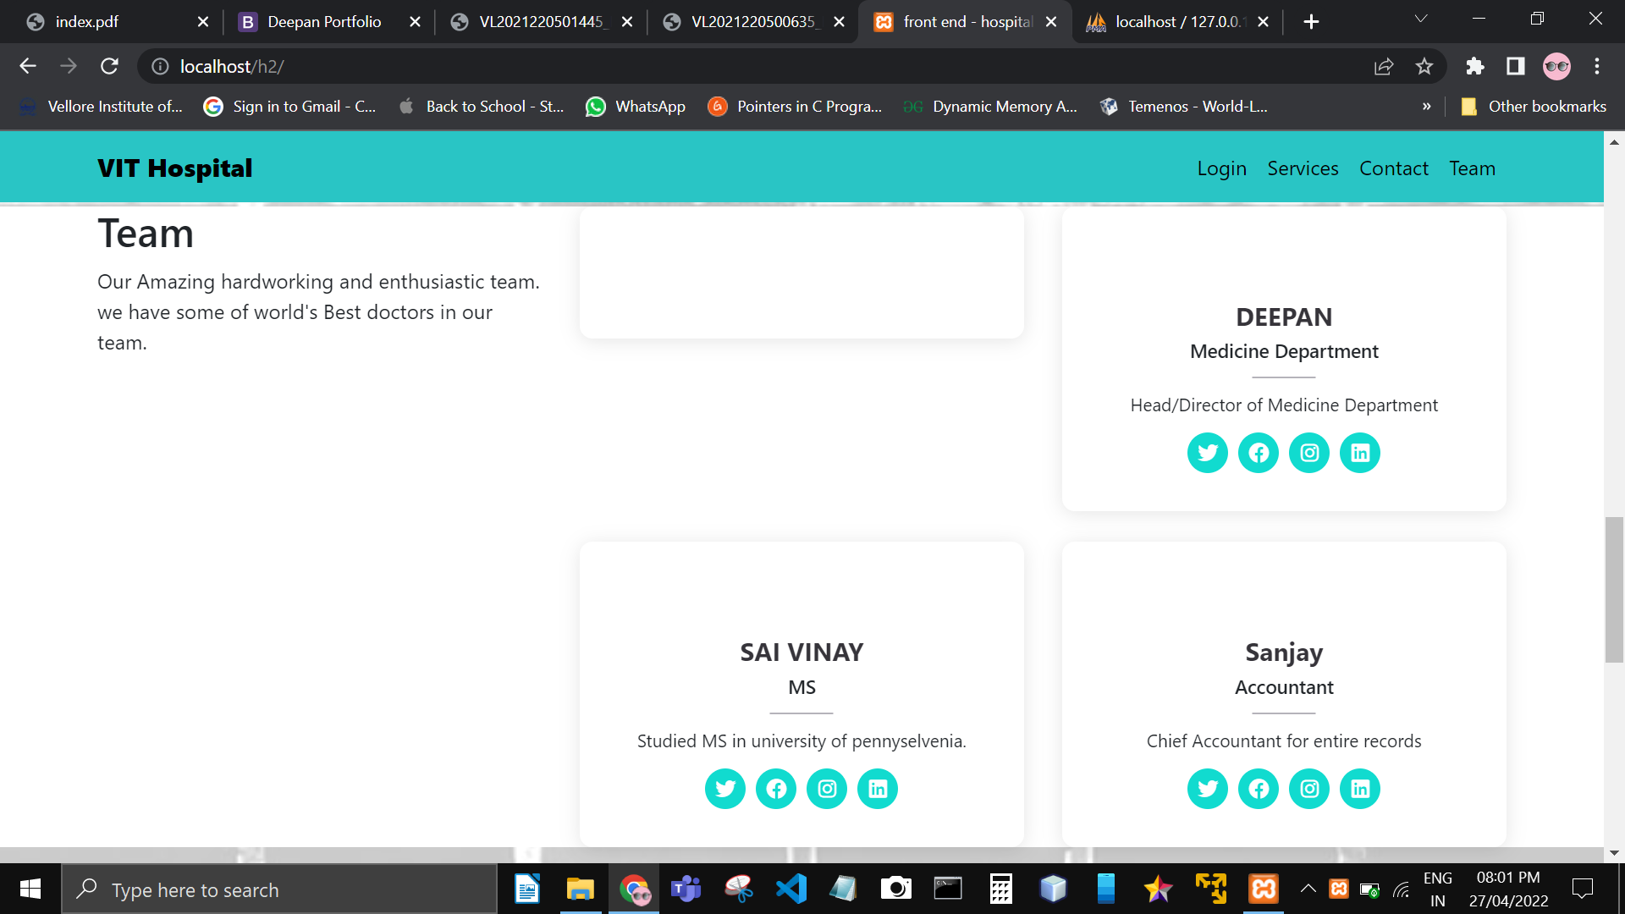

**Login Page for patient, doctor and admin :**

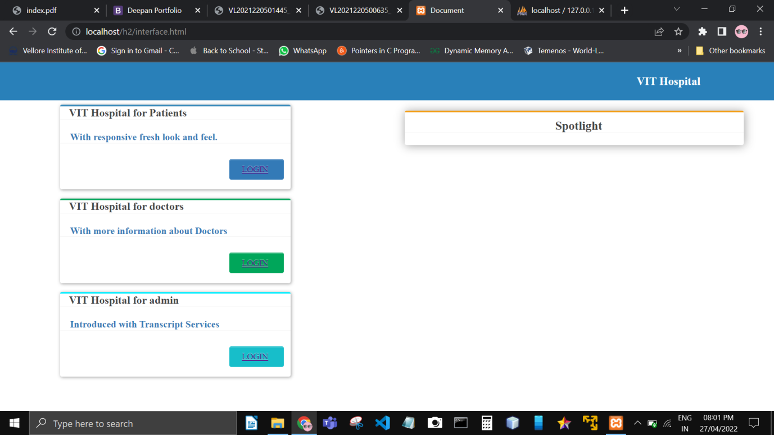

**Patient Home screen after login :**

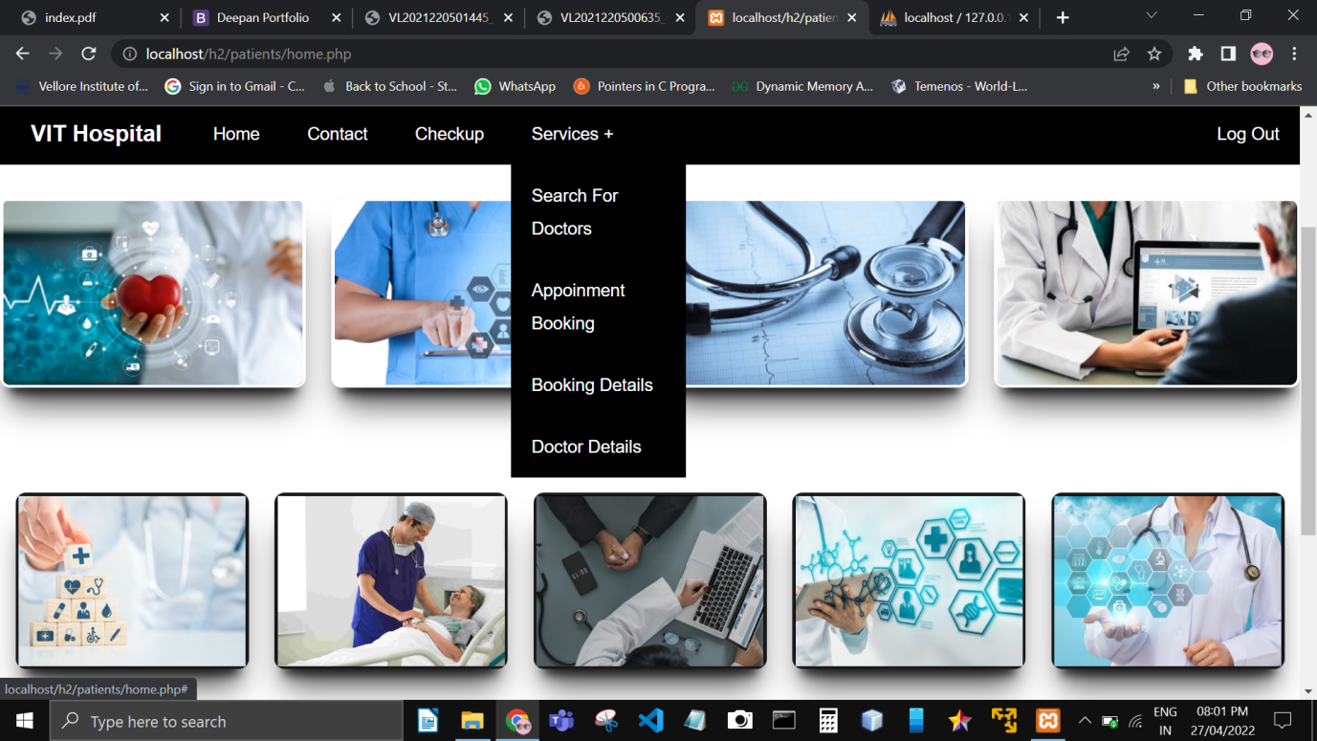

**If patient need to contact admin for any details they can use contact us page**

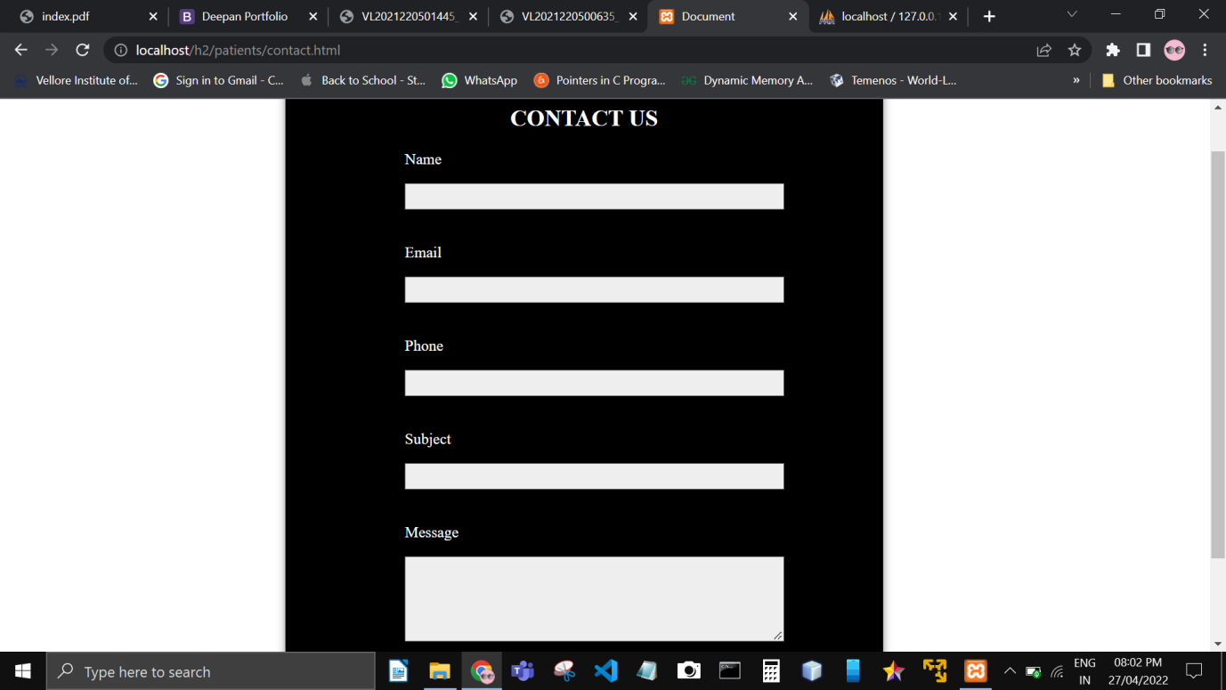

**Patient can search the doctor**

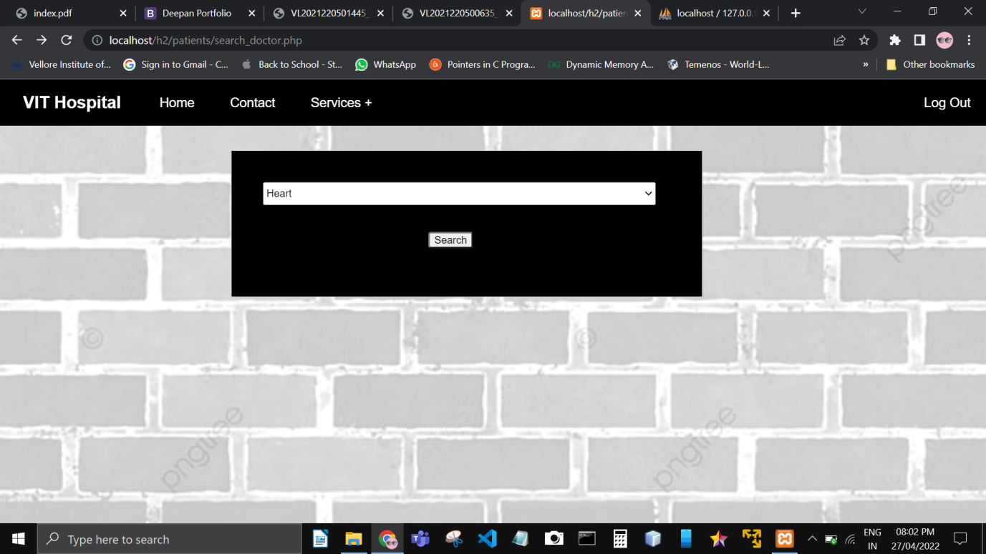

**.**

**They can book the doctors according to expertise in :**

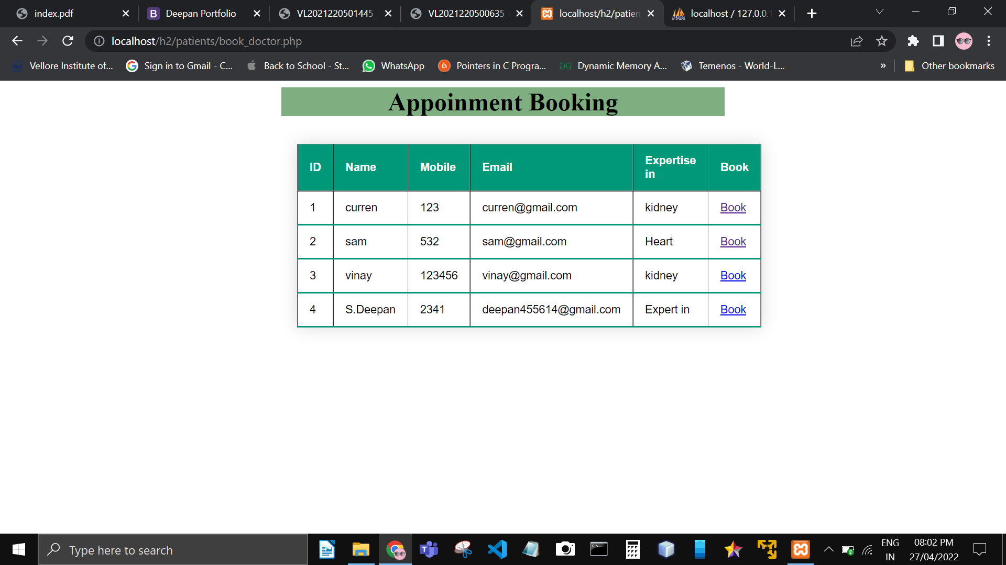**.**

**Here is the appointment screen :**

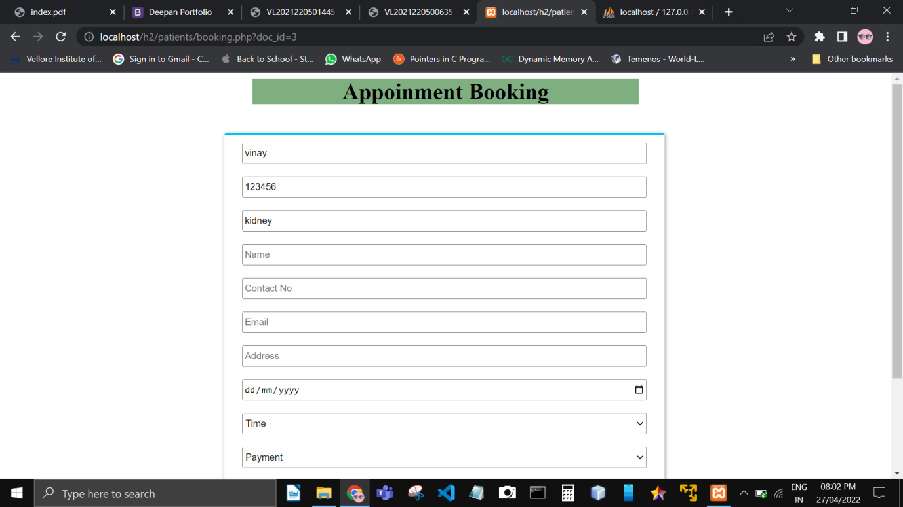

**Patient can view the doctors list with hospital names :**

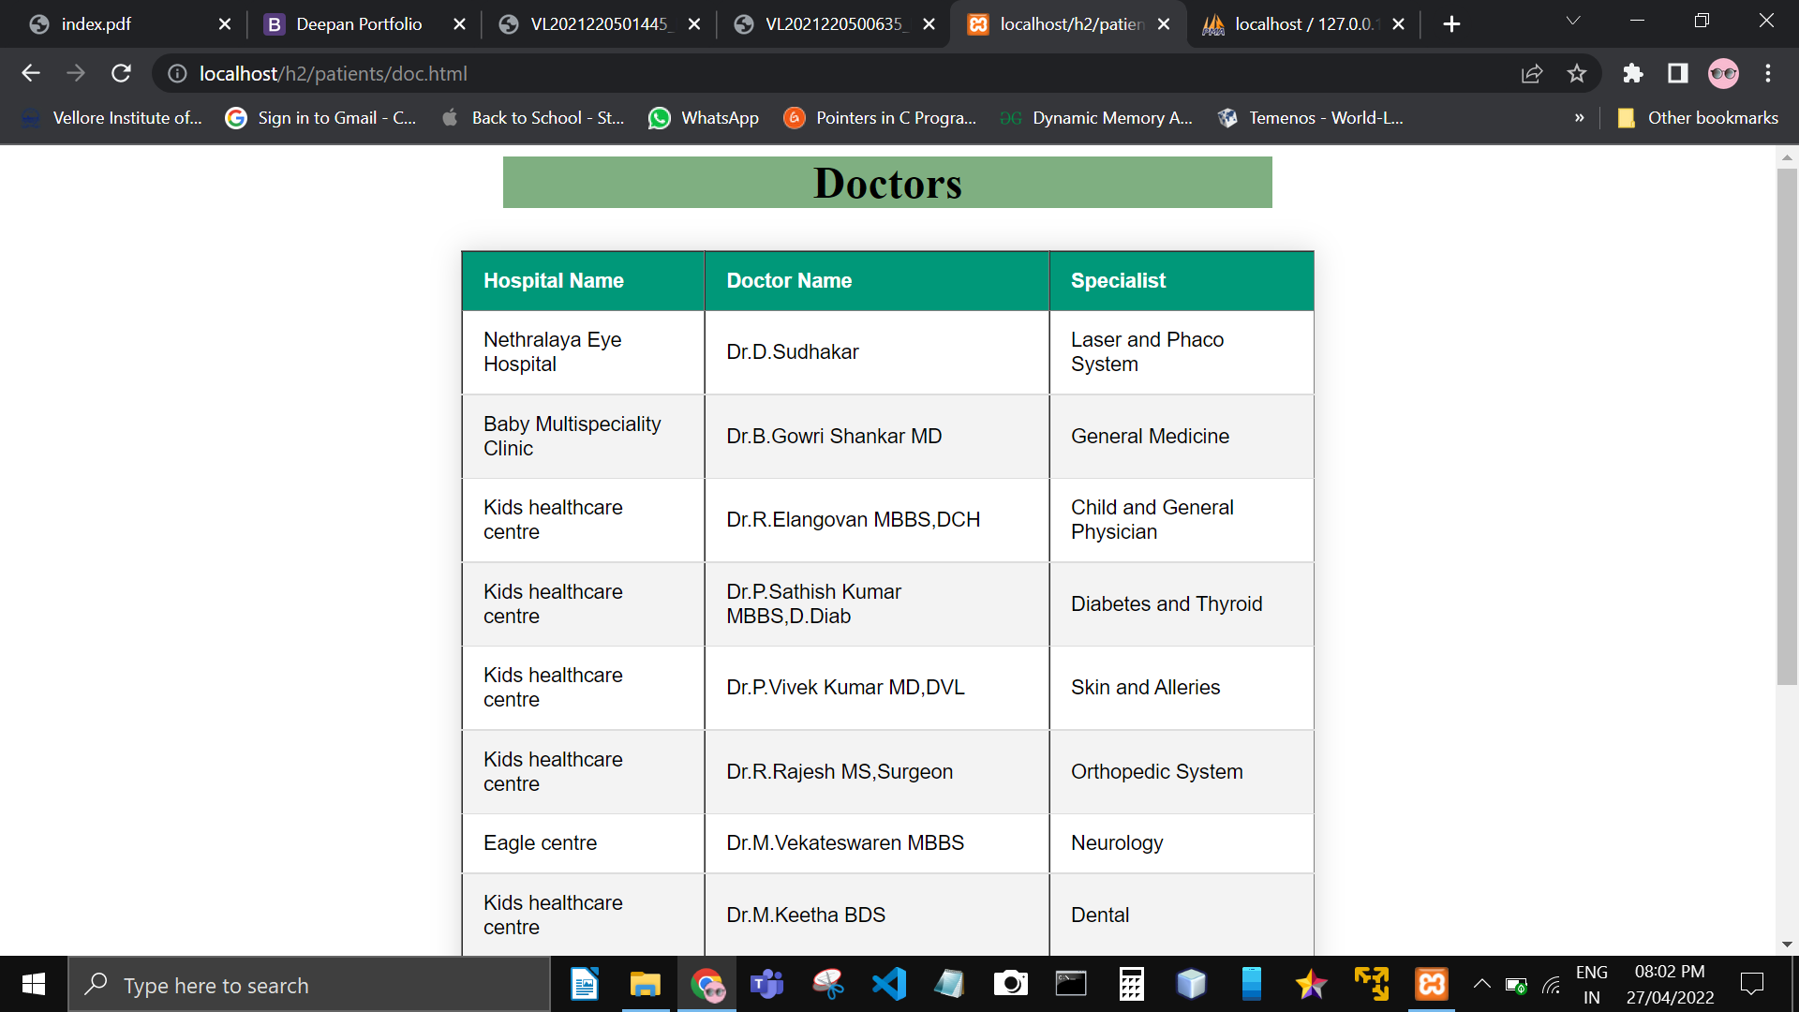**.**

**Patient can predict the disease with these online symptoms check :**

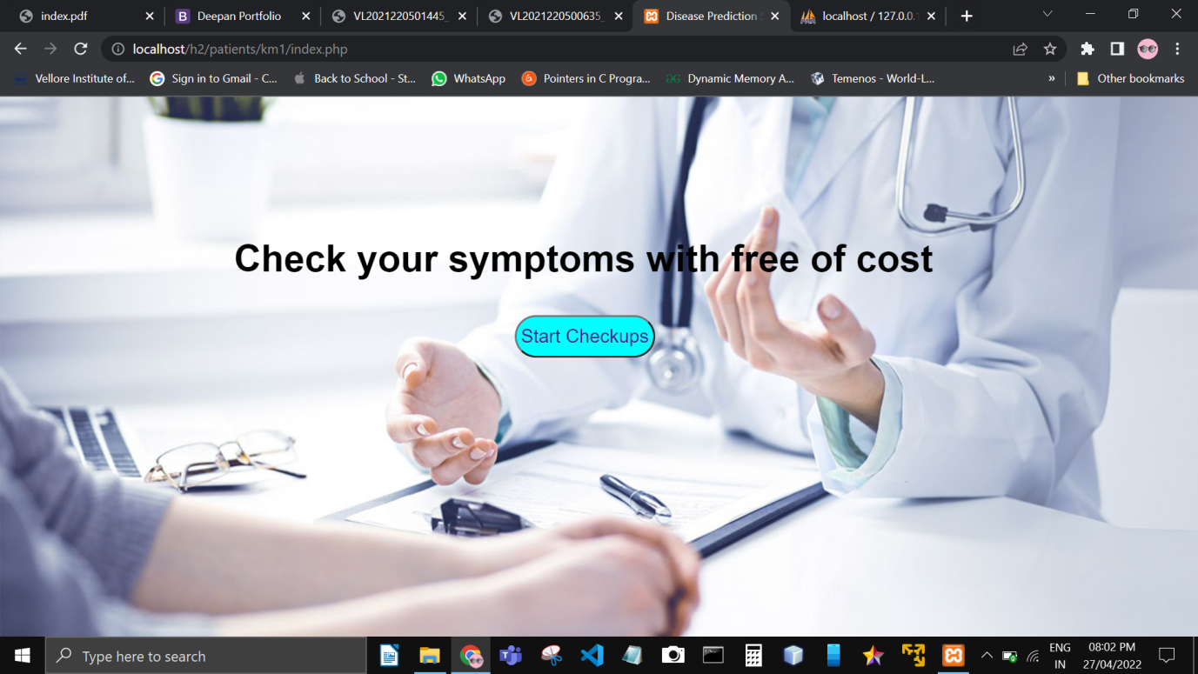

**They can click on the body parts where the pain occur**

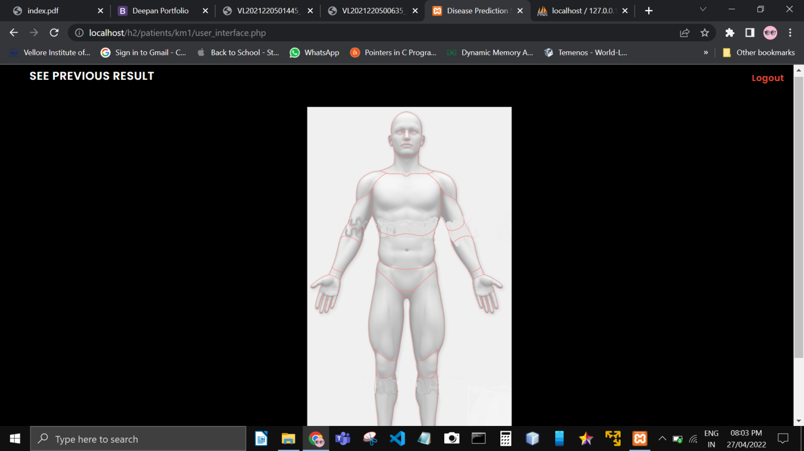

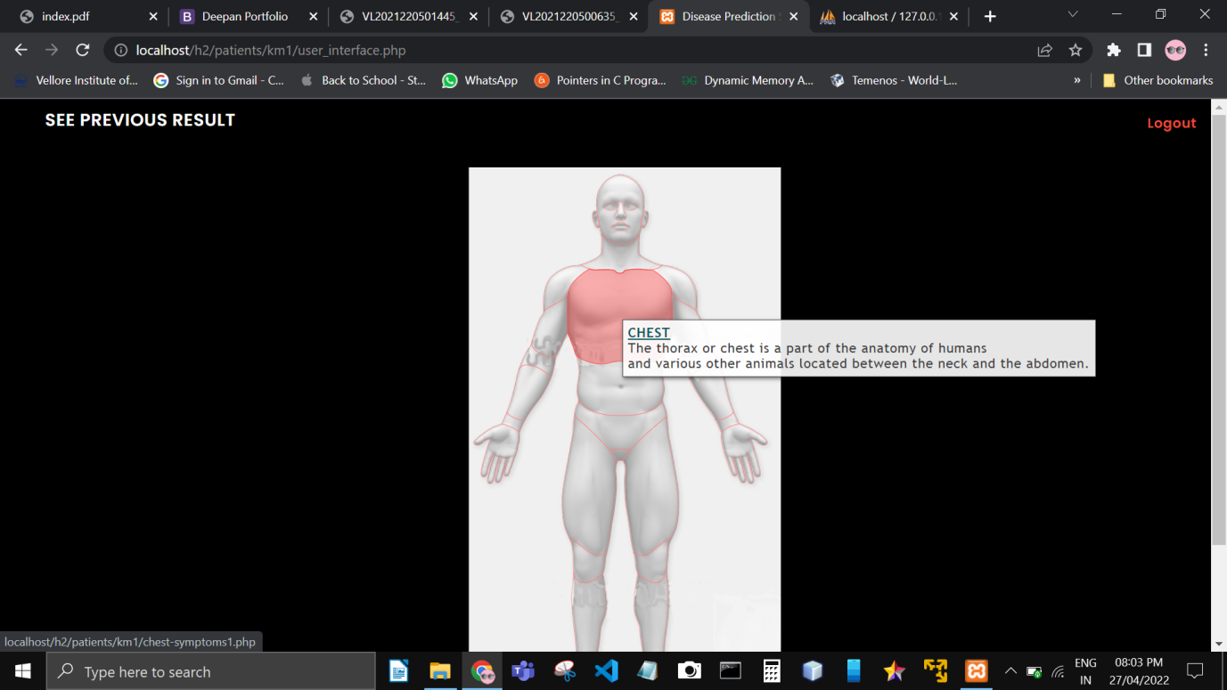

**Here are the list of questions asked to the patient to predict the disease :**

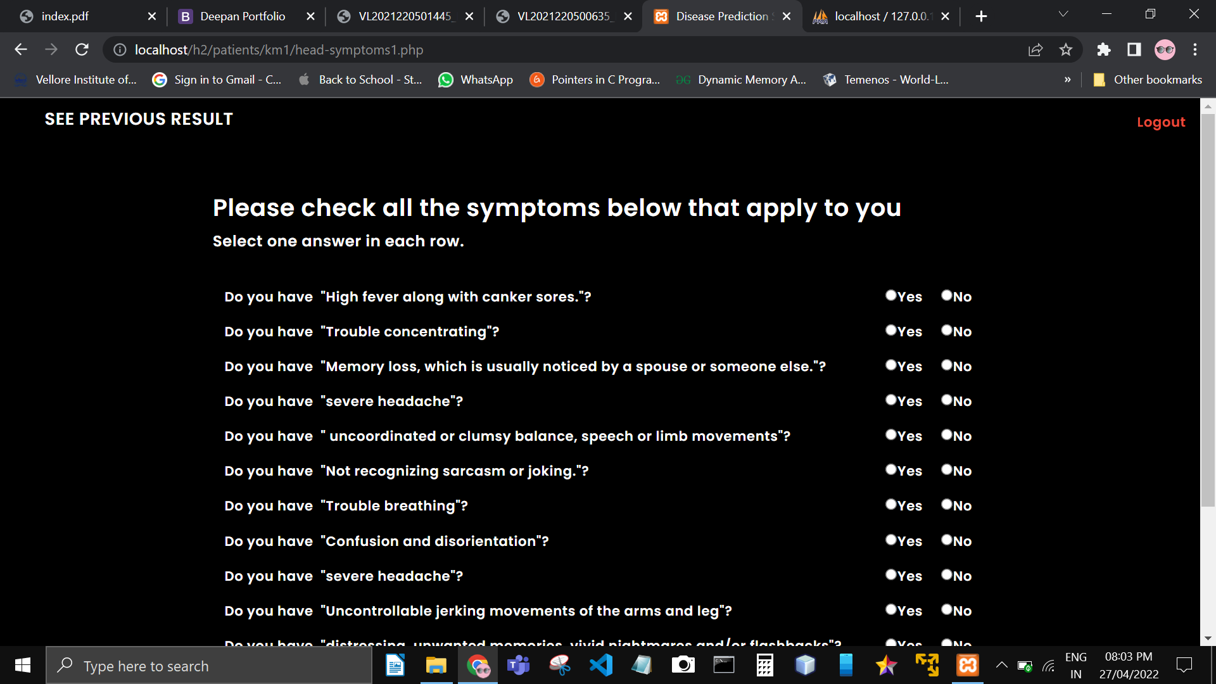

**At final patient can view there disease with there symptoms :**

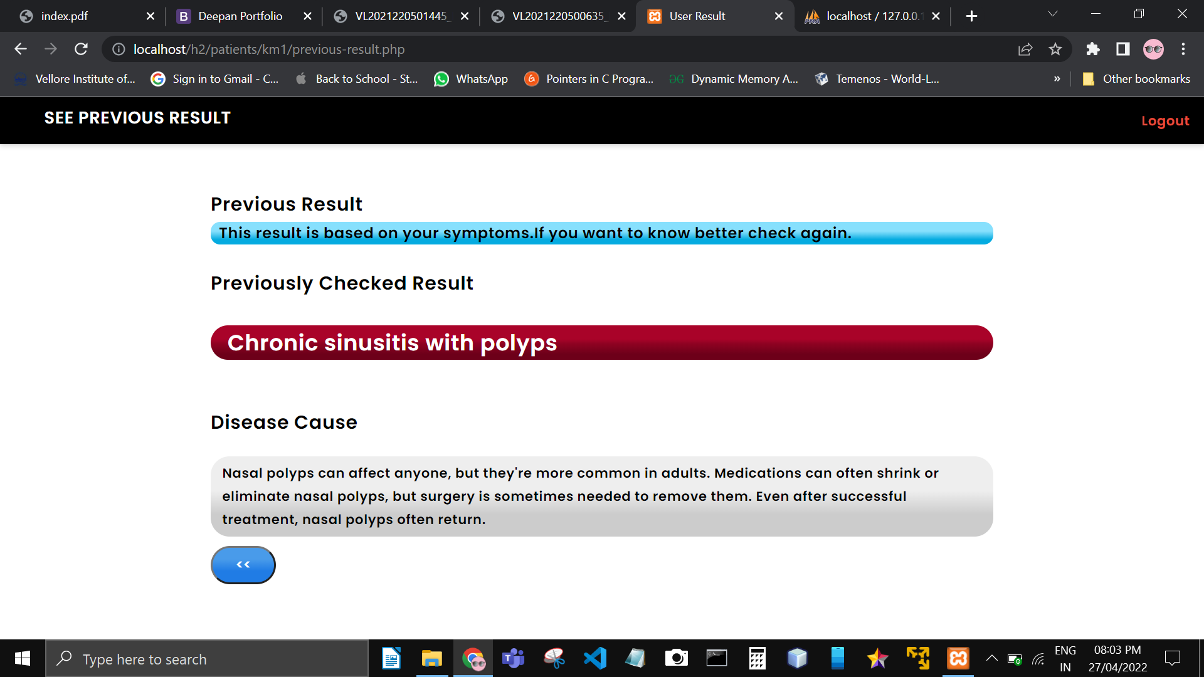

**Home screen for admin Module**

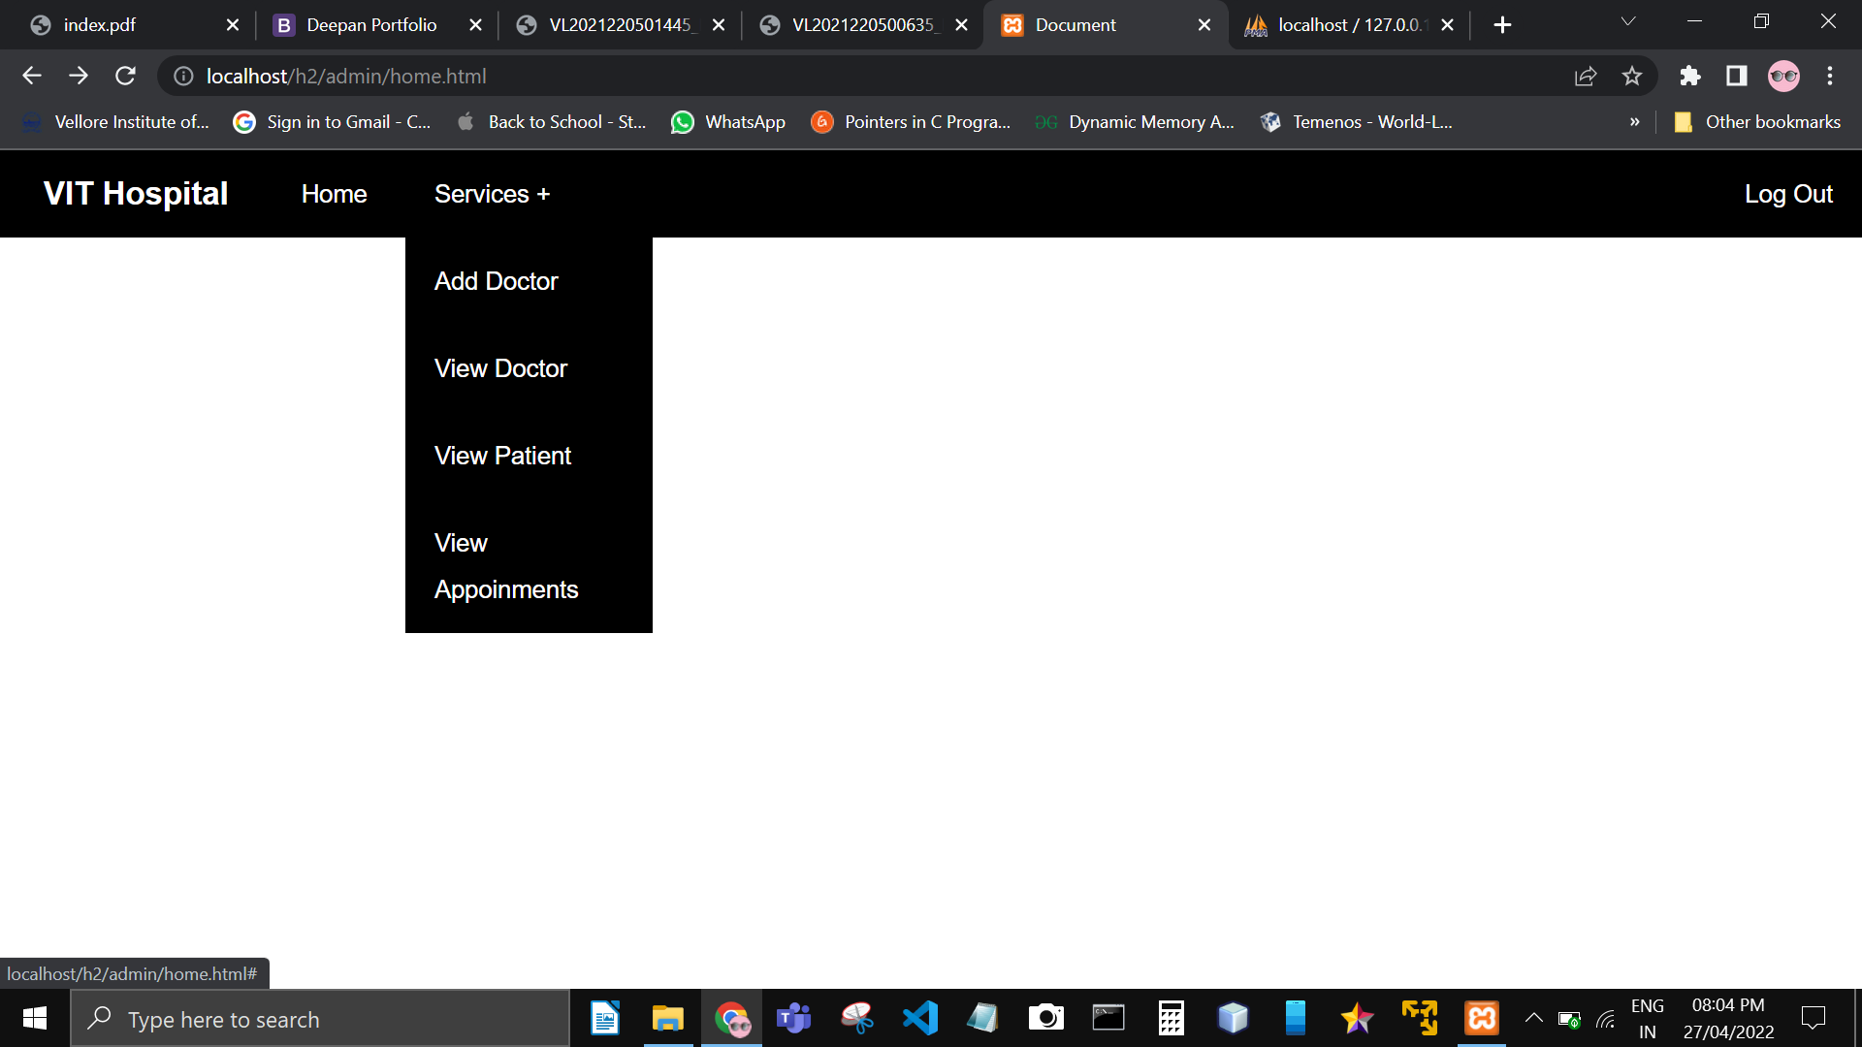

**Here is the admin module where he can add doctors and view doctors :**

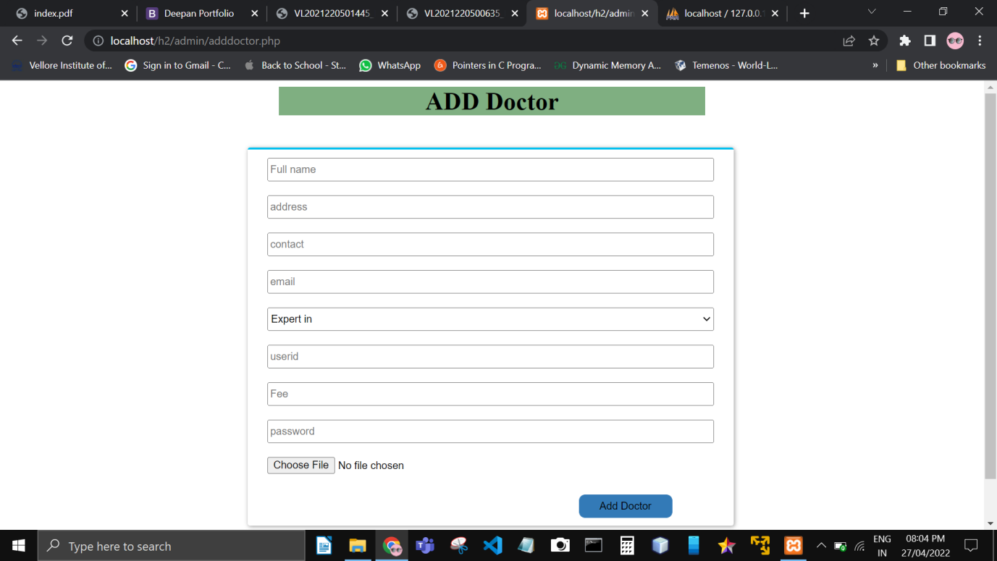**.**

**He can also search for the customer details :**

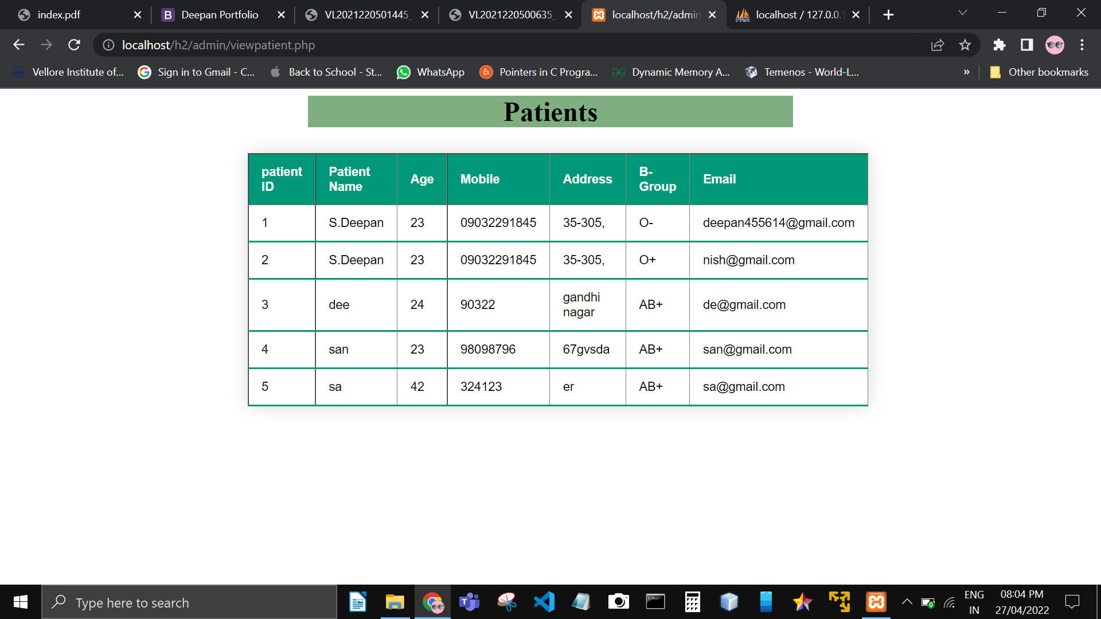**,**

**He can able to view the booking module :**

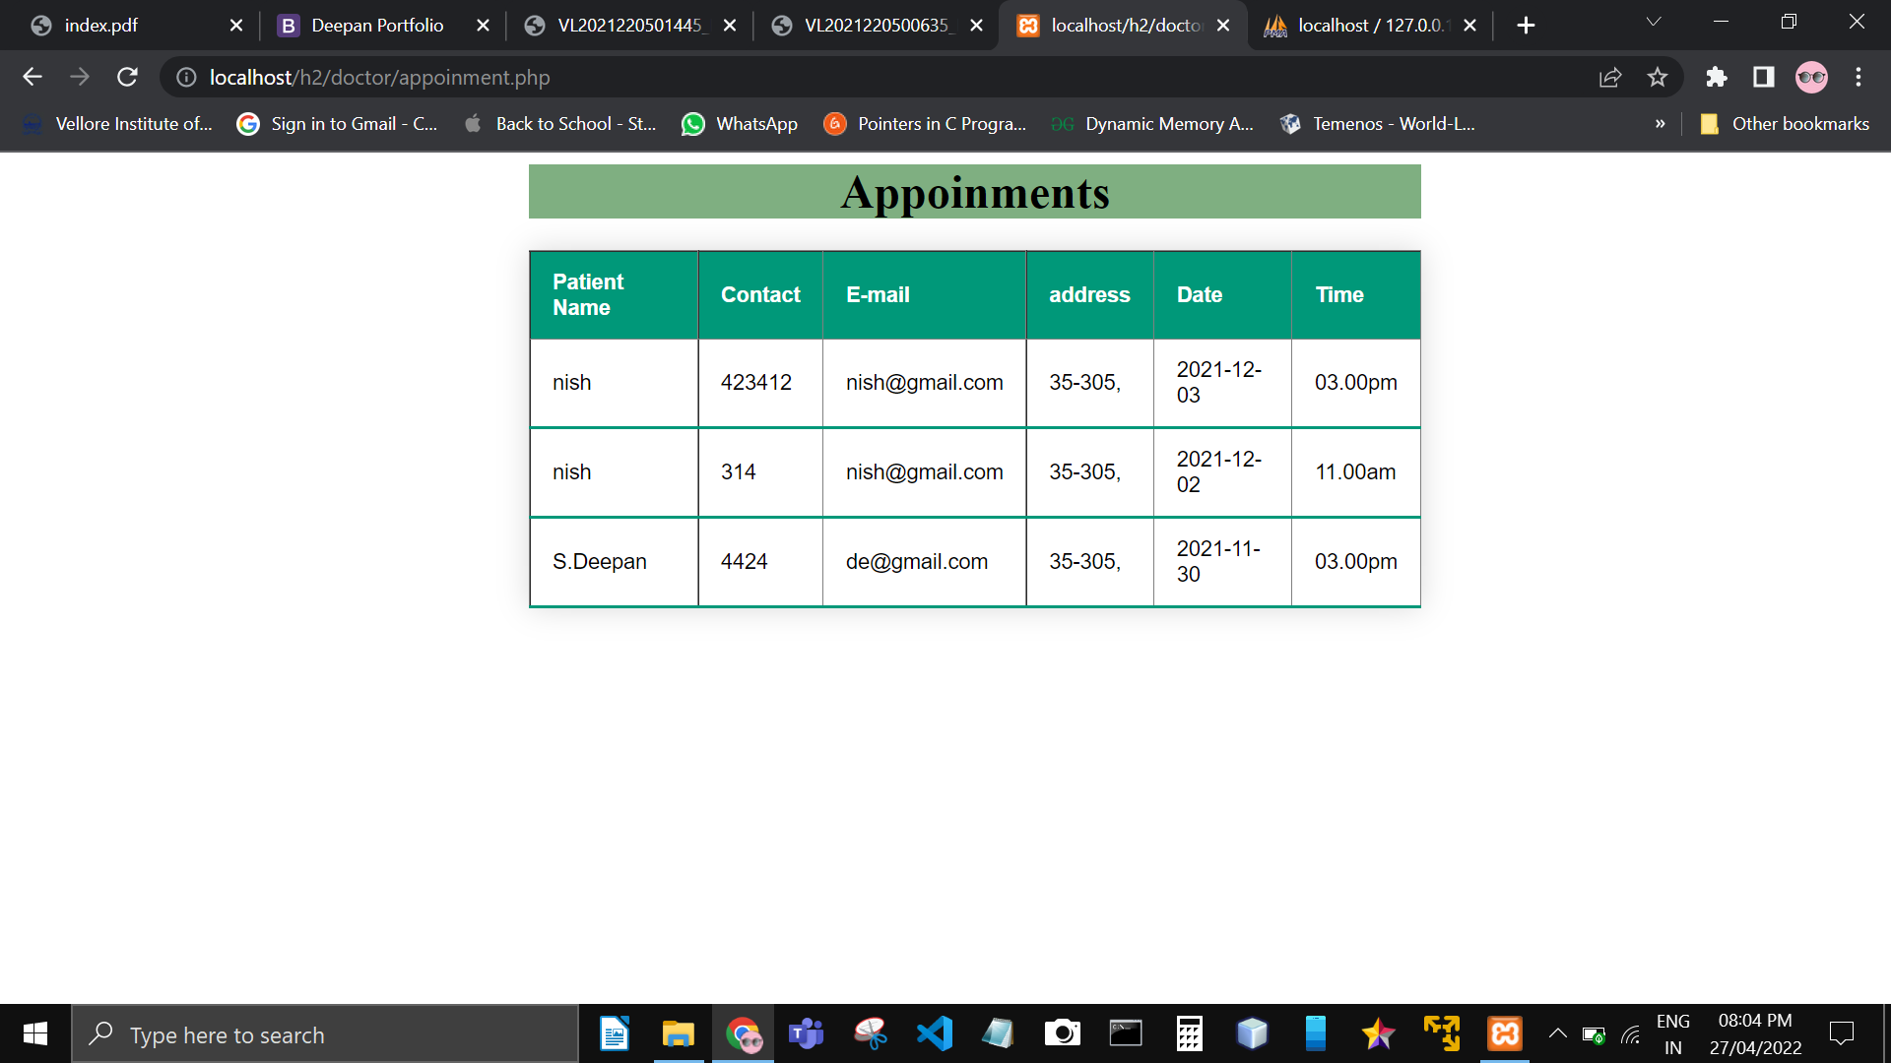

**Here are the list of doctors which was added by the admin :**

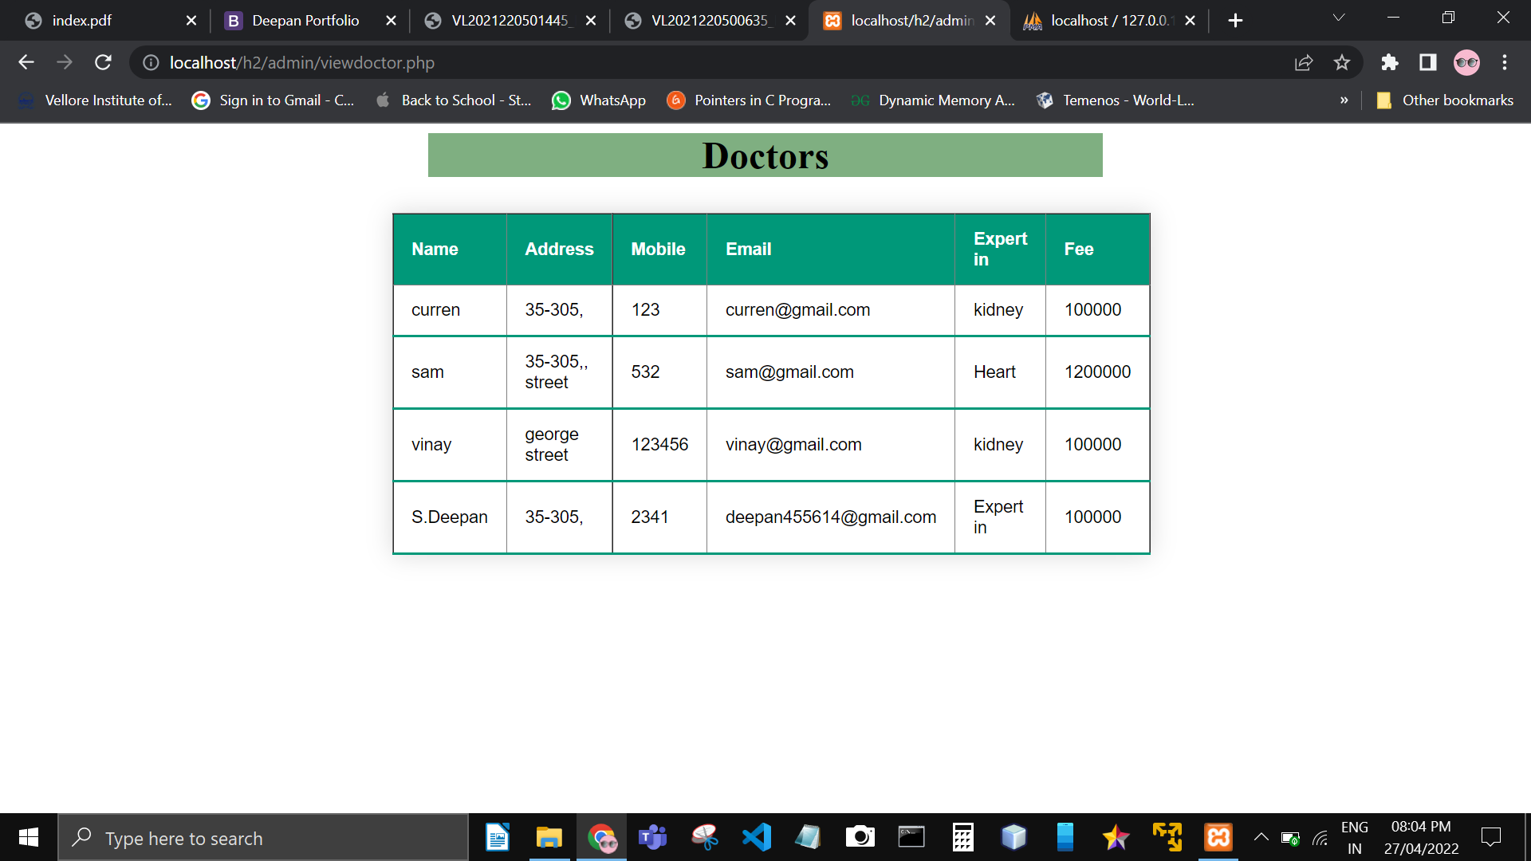**.**

**Here is the doctor module he/she can view there appointments which was booked by patients**



**Doctors can able to see the customer details in his/her module by using search operations :**

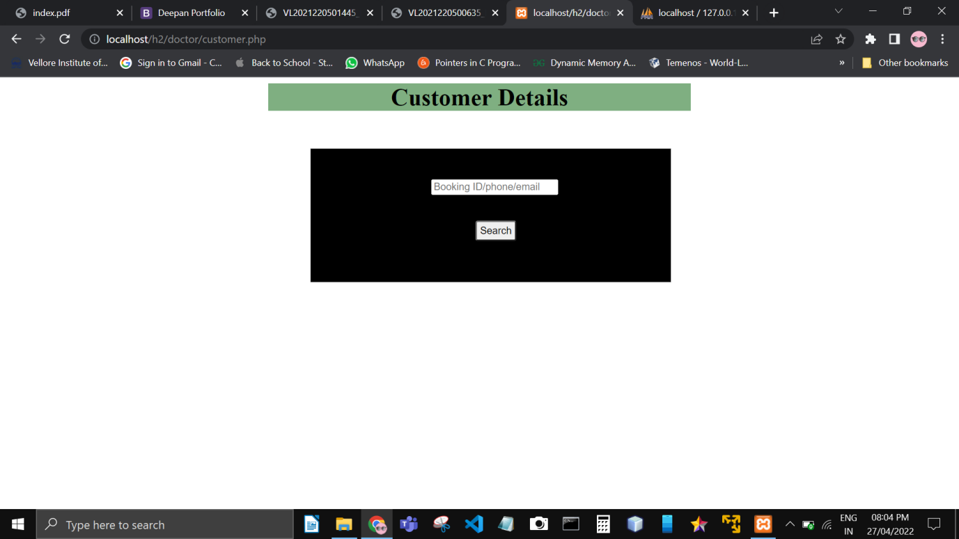

**These is the data set for the whole project**

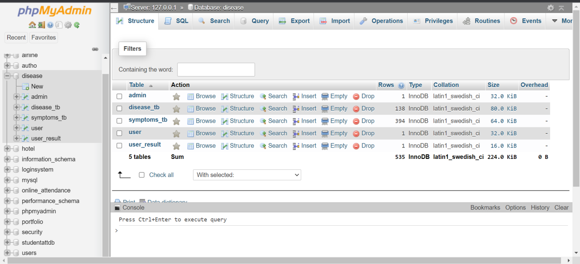

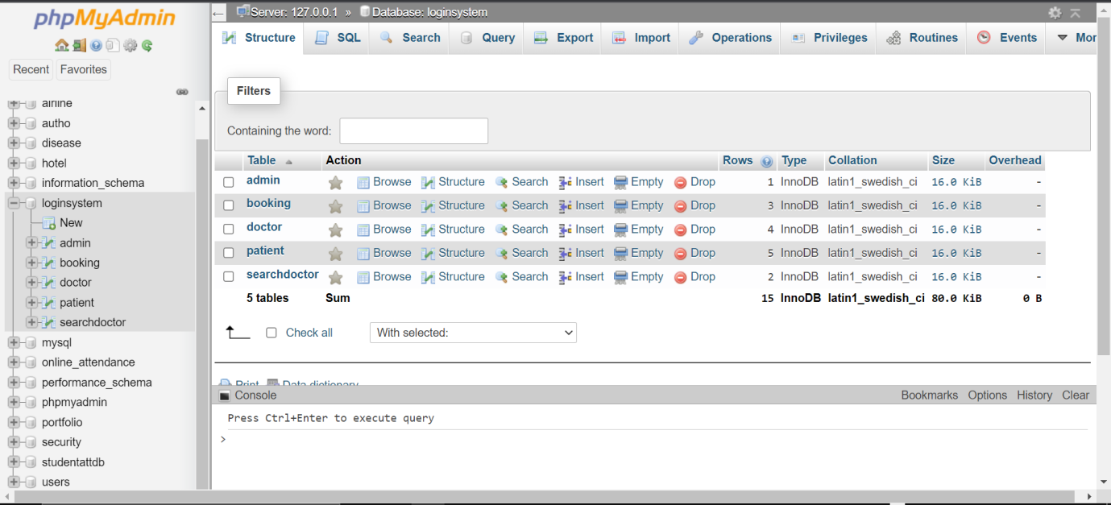

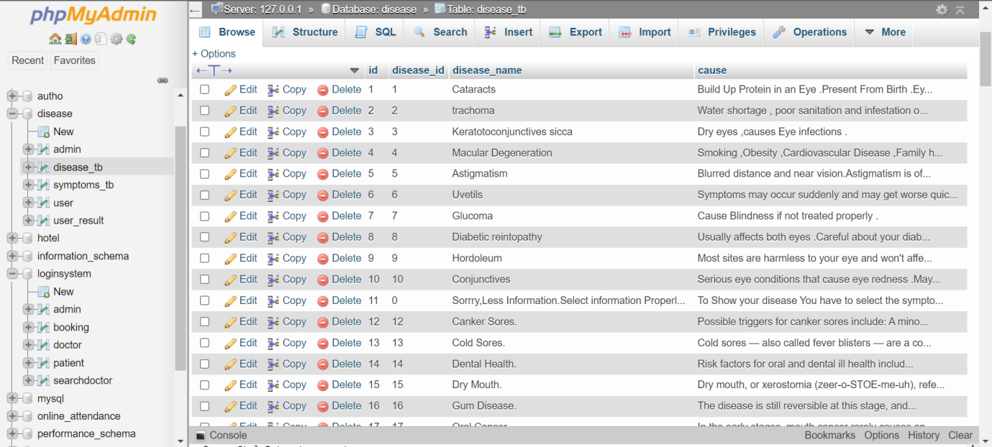

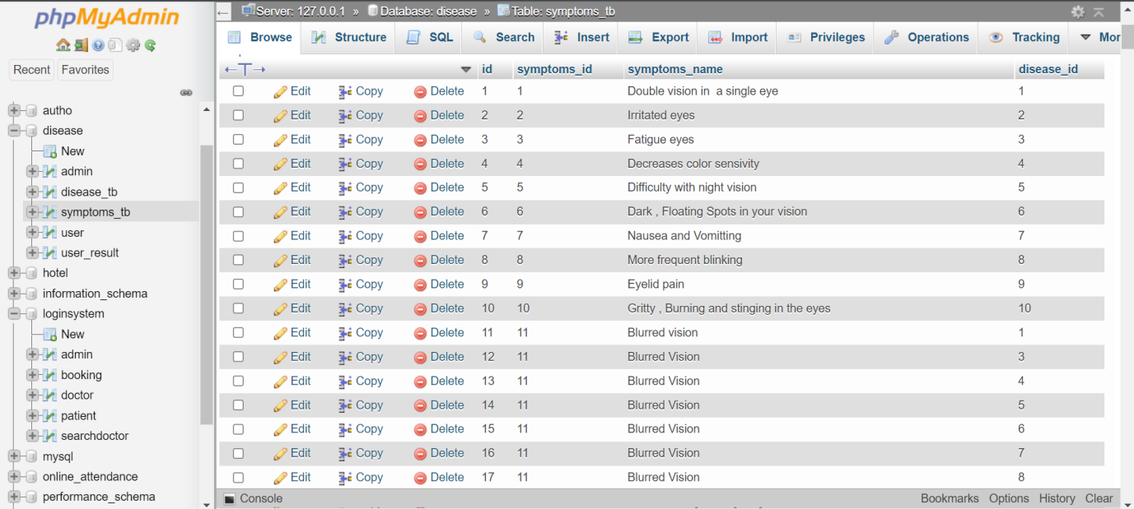

**Testing**

**For testing the module we have used Katalon studios software :**

**Here are the test case for the check up module. First it navigate to given URL and go to the check up page and see the disease.**

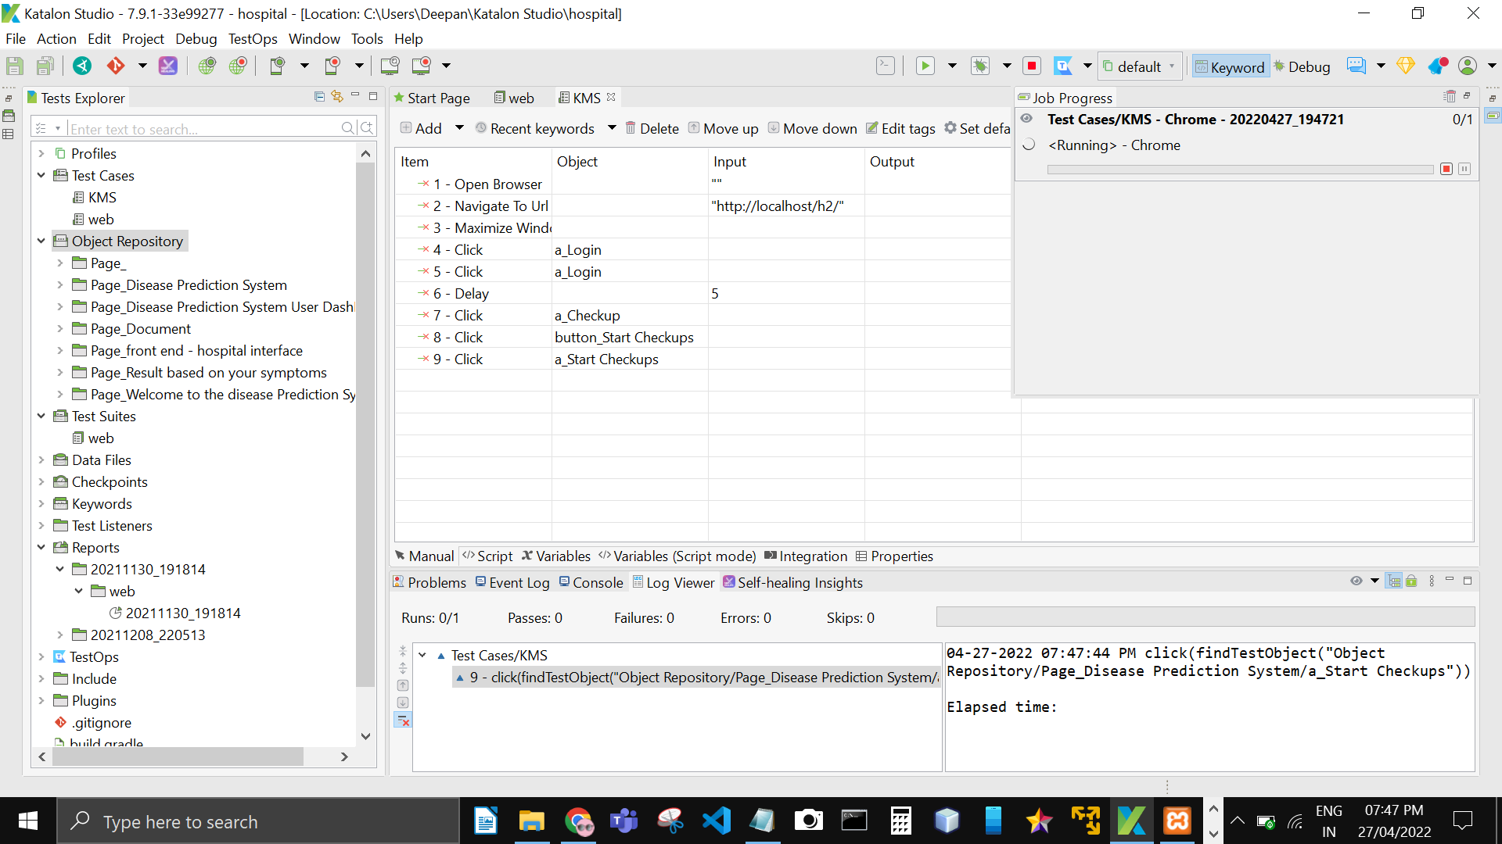

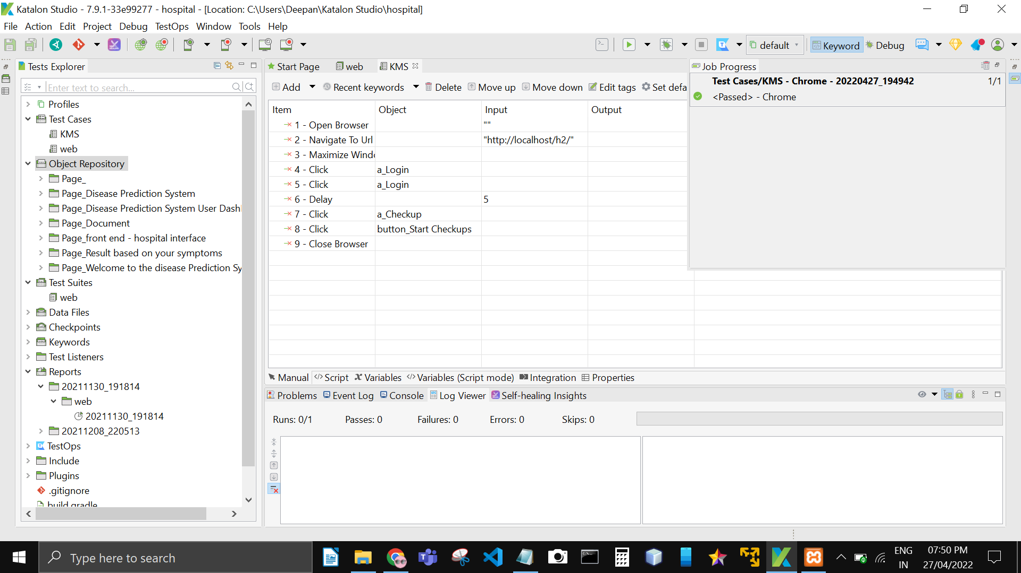

**After generating test case the list of test cases are added to test**

**suite and it got successfully**

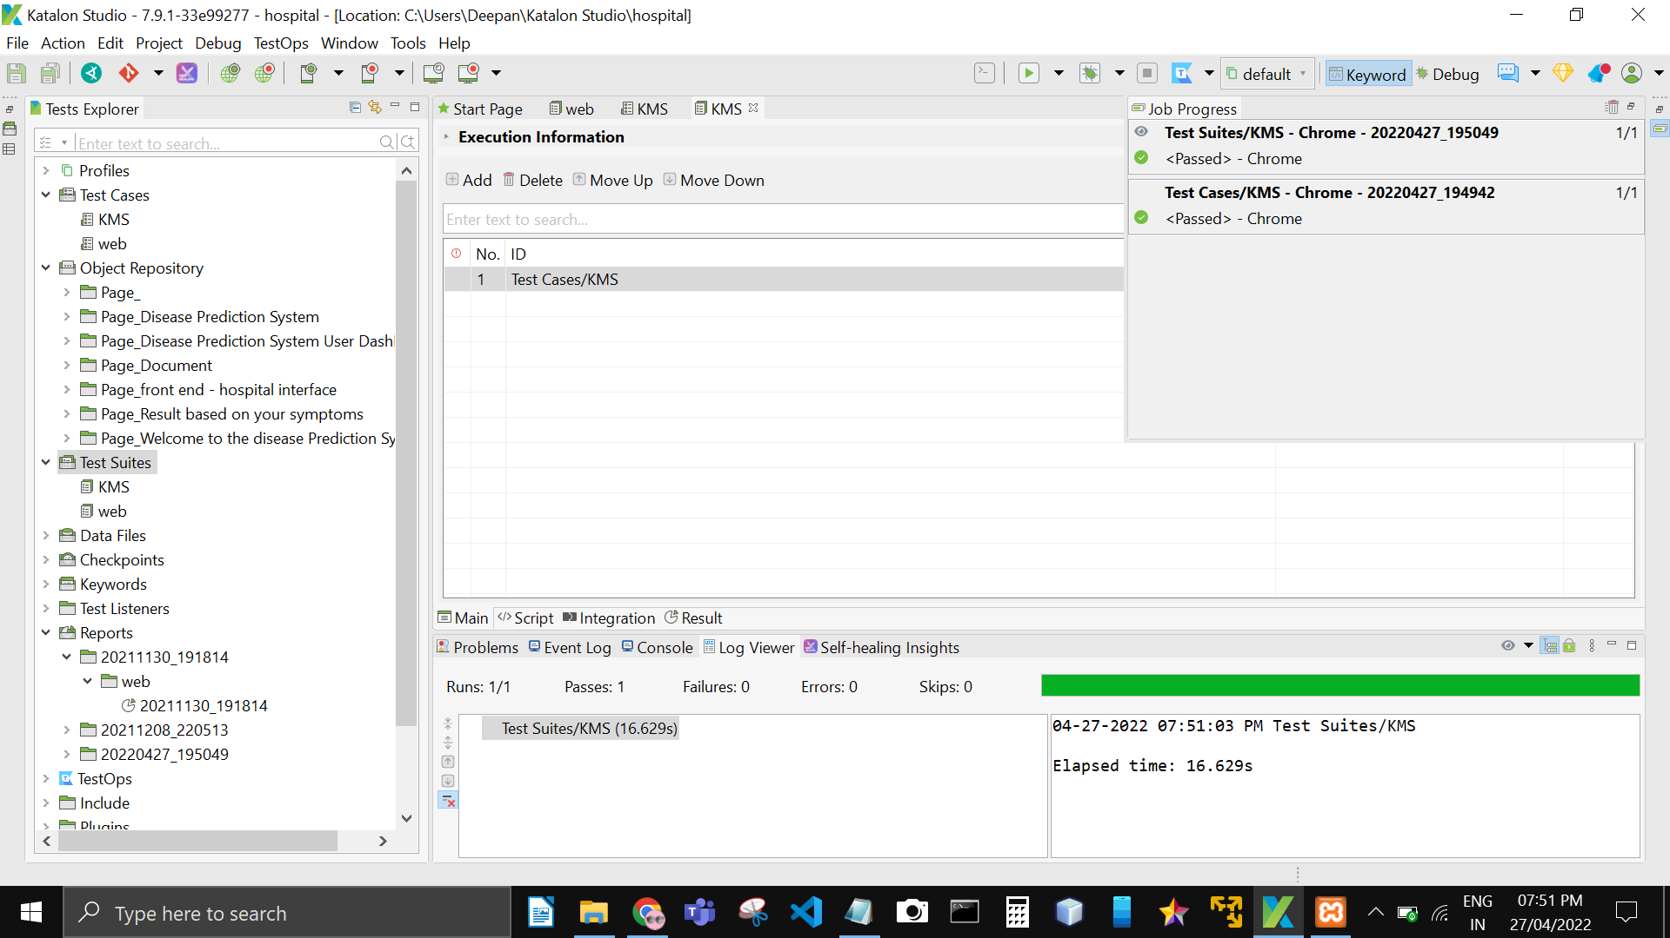

**Here is the final test report for the module in PDF format :**

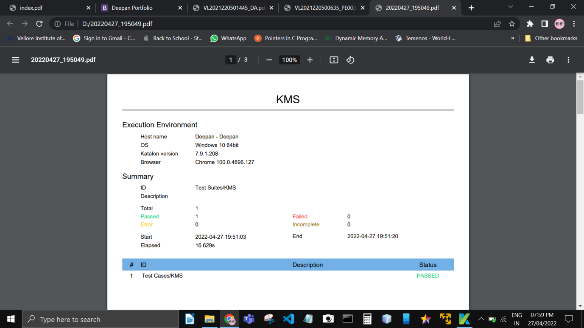

**Conclusion**